Exhibition Proposal on African American Literary and Art works
Student Name
Institution

Abstract
African American Literary and Art works
Seton Hall University through the Walsh Gallery has the potential to expose its students to wide learning opportunities through art. These learning opportunities can be achieved describing various literature and visual arts of the African-American community. The exhibition will have the role of making the audience aware of the 19th-century art about slave narratives. As a teaching art exhibition, in particular help students to understand historical aspects and African American cultures better because of the intellectual enrichment they achieve through art. Furthermore, the exhibition helps to bring into focus this group and reduce the negativity that sometimes is directed towards a good number of individuals within this part of society. I will be borrowing some artifacts that relate to African American art from the Newark Museum and Brooklyn Museum that will be shown at the Walsh Gallery. They will include sculptures photographs, paintings, and important monuments. I will use car shipping to carry my objects to Walsh Gallery at Seton Hall University because the shipping it does not take more cost and take a short time to delivery. The works of art in the exhibition tells the Seton Hall University’s students about the unique stories they tell about the lives and culture of African Americans. It will confine its context to the mission statements of Seton Hall University where most of the exhibition will be provided in a way that makes the students make a better learning about African American arts.
The African-American experience will be shown on the artifact where specific paintings will be used among the available artifacts. The paintings will be chosen such that they have images and pictures of how the Africans and Americans had relations during the slavery era. This approach will make the exhibition be of importance to the audience where memoirs by people who had escaped from slavery will be used such as Frances Bok’s book. The picture that will be brought about should be one that challenges the prejudice towards black people, which paints them as people not worth being accepted. My exhibition is especially important today because racial tension is higher. The exhibition will be guided by a panel with the purpose of presenting the themes of the gallery.
The exhibition will be of relevance through the connections that would have been made in the minds of the audience including the slave narratives that will have been brought clearly. The focus will be on the role of African Americans in the larger American society and what it means to be an American. According to the mission, the gallery aims at enhancing the intellectual value of Seton Hall University and the greater community through dynamic, interdisciplinary exhibitions of exemplary artistic and cultural value, which will have accomplished the aim of the exhibition.

Exhibition narratives
The artist of the narrative, African American Literary and Art works is meant to convey message of his investigation about various literature and visual arts of the African-American community to the audience. The responsiveness of the site is done in a way that it will give the viewers information and the theme of the exhibition. A nylon rope will be used to hang a background that will be portraying the theme of the exhibition. The background will be used to show the members about the relationship between the American and the African. The background image will cover the front page of the gallery where the viewers will be watching. The background picture will showing wirings “contemporary African American literature” showing the current living together of the Americans and Africans.
Drawing with the various pictures of the African American culture will be displayed in the background. The various tables that will be set for the exhibition will also be having the same pictorial drawings. The cultural practices that will be shown includes marriage which is a major issue among the two races. However, this disparity is narrowing due to the intermarriages that has been experienced between the two tribes. The pictures will also address the cultural practices such as music in the African America culture. A monument of African American Memorial Statue will be unveiled showing the relationship and closeness of the African American will be placed near the end of the major background photo.
The size of the wall and floor area covered is important as it help in provision of the space for the whole exhibit. The floor area to be covered should be enough to house all the exhibition resources such as the pictures to be displayed. The area should be enough for the occupants among which are staff and the invited guests. The space should also be enough to enough for the displays to ensure the pictorial drawings are not deformed by inadequate space or some parts are left invisible by the viewers. The floor space that will be consumed by the exhibition is 40m by 30m. The room is four walled with a door in one of the shorter walls. The exhibits will be placed immediately after the door at the start of the two longer wall. The pictures will be displayed in the walls of the room and the background will be in the side of the room.
The exhibition will have the physical pictorial drawing that will be conveying the message of the cultural practices of the two tribes. The picture will be stationary and will not moving. However, having a moving picture will bring the theme to the viewers easily more than the stationary pictures. Therefore, a projector is of great importance in displaying such pictures. A part of the frontal part that will be covered by the background picture will be left to display the video of the various cultural practices and the interactions of the Africans and Americans.
The monument will be made of a stone caving. The stone caving was chosen because it is cheap and also its can easily be set into various carvings. The stone was then painted so as to convey the information and the theme of the exhibition. On the other hand, the monument was to be handled carefully to avoid breakages that could result to health hazards such as injury and other forms of accidents. The paint to be used was to be able to dry with a small duration of time so as not to stick to the viewers who may be willing to feel its texture or touch it. The monument and the other printed and painted pictures do not have any other health implication to the viewers or the staff members who will be in charge or giving directions to the guests. Also, the background picture will be inform of a banner and therefore avoid sharp objects or piecing will preserve the message to be portrayed by the picture in it. The light that will be produced by the project to display the videos is hazardous to the eyes and therefore should not be looked into directly to avoid eye damage. This can cause short term or long term eyes problems.
Lastly, video documentation of the artist installing the drawings will be played on a loop on the second floor to both contextualize the public installation as well as promote the exhibition outside of the gallery proper. Alternatively, there can be a podcast that visitors may be directed to by use of a QR code on a wall label or object label. The URL can also be embedded within the gallery’s website to provide remote access to the video. While not specifically part of the installation, the accompanying video documentation will demonstrate the physicality required to make the Space Drawings and the transformation of African American Literary and Art works. The social media livestreaming can also be used to ensure that the distant guests get information about the exhibition. This will also be a method of marketing the exhibitions and sharing the knowledge with the distant clients.

Programs
The exhibition will be programmed by the artist that will be both directed at both students and the general public. The talk will be facilitated by the Curator Jeanne Brasile.
The gallery management and all other aspect of curating will be discussed by the curator. The curator will also discuss the exhibition development with the students studying the fine art, art history, design or enrolled in gallery management class.
Curator will also ensure effective working with the faculty so as to ensure correct interpretation of exhibition in context which facilitate varying curricula.
Target audience
The audience of the exhibition will be in the gallery and others will be far in various parts of the world. All these audience will be having access to the exhibition. Public relation will greatly help to ensure that those who are not in the gallery are able to access the happening in the exhibition.
The major target groups or audience of the exhibition are:
- Constituency of community members
- Faculty and staff members
- Students particularly the ones studying fine art and art history.
Artist and curator both have audience in Essex, Passaic and Hudson counties in New Jersey, Brooklyn and Manhattan.
Public relations
The exhibition will be having members from various parts of the world who will not be physically available for the exhibition. Such members will access our content due to the vigorous public relations that will be conducted. The public relations will be done through various ways which includes direct emails, direct post cards mailing, social media and press releases that are distributed to the individual, art blogs, specific art critics, curators and patrons.
Design
Production of the modest tri fold catalogue with perfect binding, a greater number of images and various essays whose source is curator and also from scholars and referencing the the work of the artist.
Video accompaniment will be there to ensure additional context in which to interpret the work that could be tailored meeting the curricula expectation. The professor will be encouraged to attend the exhibition so as to include it in the coursework. The artist talk will be recorded on video as a method of documentation of the exhibition. The video can be linked to online video streaming websites such as YouTube or Vimeo.

The Exhibition Budget“Constant
DESCRIPTION |  |  | ITEMIZATION |  |  | SUBTOTAL |  | TOTAL
Gallery Preparation
Installation Hardware |  | O-Rings, Eyehooks, Anchors, etc. |  |  | $150.00 |  |  | $150.00
Gallery Prep |  | Spackle, Sand Paper, etc. |  |  | $25.00 |  |  | $25.00
 |  |  |  |  | Gallery Preparation
 |  |  |  |  | SUBTOTAL:
 |  |  |  |  |  |  |  |  |  |  |  | $175.00
Printed Material
Postcards |  | 5000 |  |  | $160.00 |  |  | $160.00
Postage |  | .33 x 2000 |  |  | $660.00 |  |  | $820.00
Posters |  | .50 x 50 |  |  | $25.00 |  |  | $845.00
Exhibition Brochure |  | 500 pieces |  |  | $305.00 |  |  | $1150.00
Text Panel |  | 1 |  |  | $300.00 |  |  | $1450.00
Vinyl Letters (title) |  | 1 |  |  | $100.00 |  |  | $1550.00
 |  |  |  |  | Printed Material SUBTOTAL:
$1550.
00
Personnel
Artist Honoraria |  | Artist Talk + travel, time, expenses |  |  | $600.00 |  |  | $600.00
Curator Honoraria |  | Travel, time, expenses |  |  | $600.00 |  |  | $1200.00
 |  |  |  |  |  | Personnel
 |  |  |  |  | SUBTOTAL: |  |  |  |  |  | $1200.  00
Reception Food/Drink
Food – Reception |  | 3 platters |  |  | $300.00 |  |  | $300.00
Wine - Reception |  | 75 x 3 |  |  | $225.00 |  |  | $525.00
Food/Drink for
 |  |  |  |  |  |  |  | $675.00
Attendees Artist Talk |  |  |  |  | $150.00
 |  |  |  |  | Reception Food/Drink
 |  |  |  |  | SUBTOTAL:
$675.
00
 |  |  |  |  | TOTAL EXHIBITION
 |  |  |  |  | BUDGET: |  |  | $3600.00

Floor plan
The floor space will be dividend to ensure it can accommodate the exhibits and the viewers in the gallery. The part near the long walls will have tables that will have the exhibit that will be viewed. These are exhibits that can be placed on the table like artefacts and the viewers can be able to access them easily or see them easily. The other pictures will be mounted on the walls of the room. The size of the pictures is dependent on the place it will be mounted on the wall. There will be a path in between the two sides with the exhibits and there will be seats in the frontal part of the room. This parts will be used by viewers who will be willing to learn from the video that will be displayed on the screen by the projector.

Exhibition timeline
The tasks are carried out chronologically as follows:
- Idea development
- Concept writing
- Target audience identification
- Working title identification
- Allocating tasks
- Collection material audit
- Non-collection material audit and development of budget
- Research
- Design layout
- Catalogue design
- Plan opening
- Install exhibition
- Opening and conducting programs
- Maintenance
- Demounting

Key staff
- Curator – the curator works as the overseer of the exhibition
Roles
- Contacting the artist and working with the artist to ensure collection of the resources to be used.
- Designing the structure of the exhibit
- Delegating construction and cleaning work to the staff members
- Ensure there is lighting, sound and views area
- Keeping exhibit on schedule
- Ensuring that the exhibition is under its budget
- Facilitating storage of the various resources such as artefact after exhibition
- Collection manager – their responsibility is basically managing the collections.
- Cooperates with the curator and other staff members to ensure exhibition work is done
- Retrieves the various collections from conservation upon curator’s request.
- Ensures establishment and standards of collections care, up to when to the display and back to conservation.
- Gives expenditure projection on the collections
- Facilitates cleaning of the various artefacts used and ensuring their condition is known.
- Gallery manager- basically these are the for the ensuring directions of the viewers and directing and giving information to those buying several artefacts
- Working with the artist and giving artist information about the forthcoming ,exhibition
- Ensuring visitors get information about the exhibition
- Managing gallery store and monitoring whatever goes out or in the store.
- He also deals with framer

Curator’s resume
Jeanne Brassile
Contacts
Professional Summary
I am an experienced curator with arts education, public arts programming and public policy knowledge. I have skills on public relations have many contacts to get in the local media to get them into the exhibition. I also possess knowledge in grant writing. Have superior speaking skills and enough personal service experience and therefore can spend much time with guests in exhibitions.
Work Experience

Education and Training

Skills
- Have excellent communication skills
- a team worker and can work amicably with other staff members
- I’m familiar with project management software
- Have knowledge of working with the digital cameras
- Possess excellent leadership skills
Hobbies and Interests
- I love art, it’s a work from within not just being a curator.
- I am a fun of watching shows and exhibitions

Images
The following makes a list of representation of some of the picture that will be in the gallery.

The background picture showing the current situation of togetherness between Africans and Americans
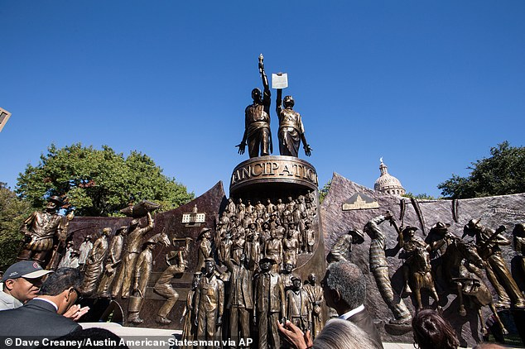
The African American Memorial Statue monument

An African Married to African
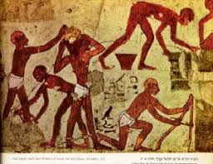

African American History Culture

The picture showing the integrated African and America in the revived generation

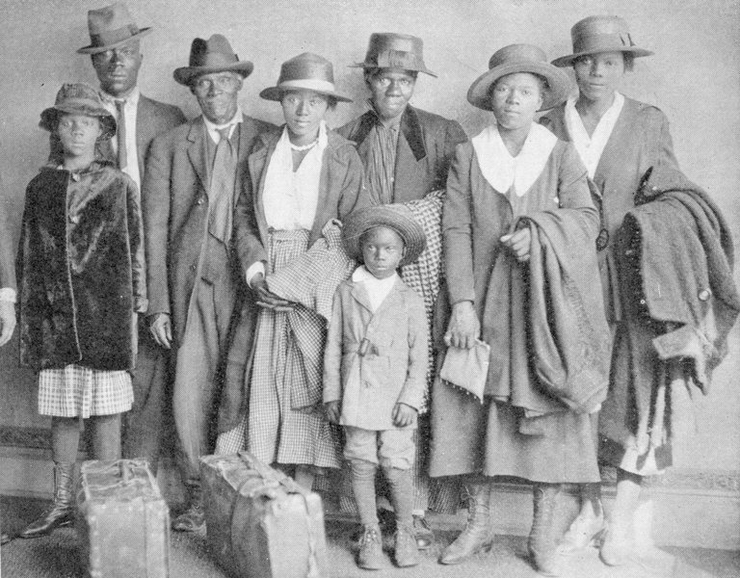

Tales of African-American History Found in DNA

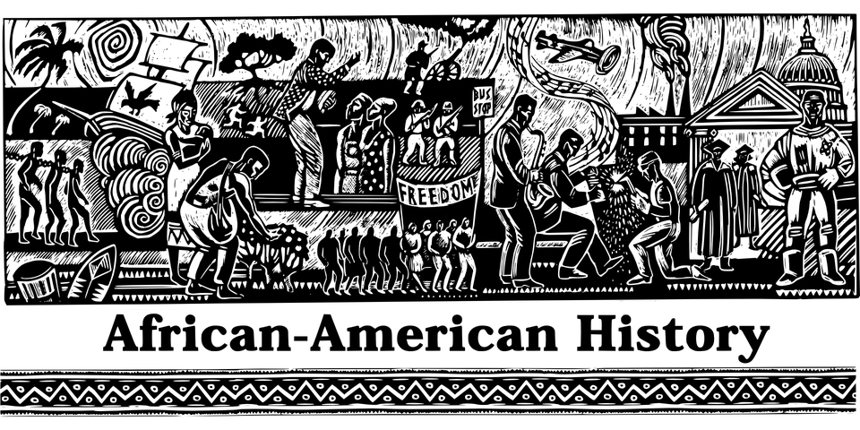
In celebration of Black History Month and African American History

Escape from Slavery: The True Story of My Ten Years in Captivity and My Journey to Freedom in America https://www.barnesandnoble.com/w/escape-from-slavery-francis-bok/1100626244?ean=9780312306243&st=PLA&sid=BNB_DRS_Core+Catch-All,+Low_00000000&2sid=Google_&sourceId=PLGoP79700&gclid=EAIaIQobChMIpOruxt2U1wIViEoNCh3UUAn4EAkYASABEgLku_D_BwE

